Day – 6
#23
import numpy as np
import matplotlib.pyplot as plt
from scipy.stats import ttest_ind

# Sample data
control = [50, 52, 48, 49, 51, 50]
treatment = [55, 57, 56, 54, 58, 56]

# Hypothesis test
t_stat, p_value = ttest_ind(treatment, control)

# Visualization
plt.boxplot([control, treatment], labels=['Placebo', 'New Treatment'])
plt.title(f'Clinical Trial Results\np-value = {p_value:.4f}')
plt.ylabel('Health Score')
plt.show()

print("p-value:", p_value)

output:
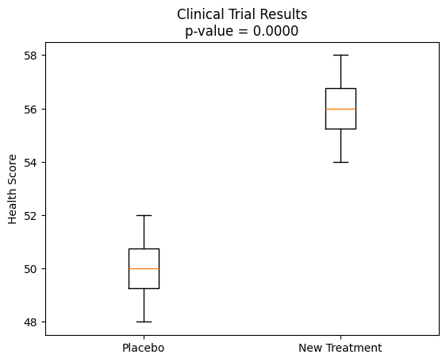
p-value: 2.45807398594218e-05
#24
import numpy as np
from sklearn.neighbors import KNeighborsClassifier

X = np.array([[1,1,0],[0,1,1],[1,0,1],[0,0,0]])
y = np.array([1,0,1,0])

k = int(input("Enter k: "))#3
knn = KNeighborsClassifier(n_neighbors=k)
knn.fit(X, y)

new_patient = np.array([[1, 1, 0]]) # example input
print("Prediction:", knn.predict(new_patient)[0])

output:
Enter k: 3
Prediction: 1
#29
from sklearn.datasets import load_breast_cancer
from sklearn.model_selection import train_test_split
from sklearn.linear_model import LogisticRegression
from sklearn.metrics import accuracy_score, precision_score, recall_score, f1_score

# Load dataset
X, y = load_breast_cancer(return_X_y=True)

# Split data
X_train, X_test, y_train, y_test = train_test_split(
X, y, test_size=0.3, random_state=42
)

# Train model
model = LogisticRegression(max_iter=1000)
model.fit(X_train, y_train)

# Predict
y_pred = model.predict(X_test)

# Evaluation metrics
print("Accuracy :", accuracy_score(y_test, y_pred))
print("Precision:", precision_score(y_test, y_pred))
print("Recall :", recall_score(y_test, y_pred))
print("F1-score :", f1_score(y_test, y_pred))

output:
Accuracy : 0.9707602339181286
Precision: 0.9724770642201835
Recall : 0.9814814814814815
F1-score : 0.9769585253456221
#32
import numpy as np
from sklearn.linear_model import LinearRegression
from sklearn.metrics import mean_squared_error, r2_score

# Data: house size vs price
X = np.array([[600],[800],[1000],[1200]])
y = np.array([50, 65, 80, 95])

# Model
model = LinearRegression()
model.fit(X, y)

# Prediction & evaluation
y_pred = model.predict(X)
print("MSE:", mean_squared_error(y, y_pred))
print("R2:", r2_score(y, y_pred))

output:
MSE: 1.262177448353619e-29
R2: 1.0
#34
import numpy as np
from sklearn.model_selection import train_test_split
from sklearn.neighbors import KNeighborsClassifier
from sklearn.metrics import accuracy_score, precision_score, recall_score, f1_score
from sklearn.preprocessing import StandardScaler

X = np.array([
[45,120,200],
[50,130,180],
[35,110,170],
[60,140,220],
[40,115,190]
])

y = np.array([1, 0, 1, 0, 1]) # 1=Good, 0=Bad

# Scale features
X = StandardScaler().fit_transform(X)

X_train, X_test, y_train, y_test = train_test_split(
X, y, test_size=0.4, random_state=42
)

knn = KNeighborsClassifier(n_neighbors=3)
knn.fit(X_train, y_train)

y_pred = knn.predict(X_test)

print("Accuracy :", accuracy_score(y_test, y_pred))
print("Precision:", precision_score(y_test, y_pred, zero_division=0))
print("Recall :", recall_score(y_test, y_pred, zero_division=0))
print("F1-score :", f1_score(y_test, y_pred, zero_division=0))

output:
Accuracy : 0.5
Precision: 0.5
Recall : 1.0
F1-score : 0.6666666666666666

